Instruction:

1. Unzip the Apache Jena Fuseki zip
2. Click the “fuseki-server.jar” (Java 11 must be Installed)
3. In the browser, go to http://localhost:3030/ and you should be able to see the server up and running, as shown below

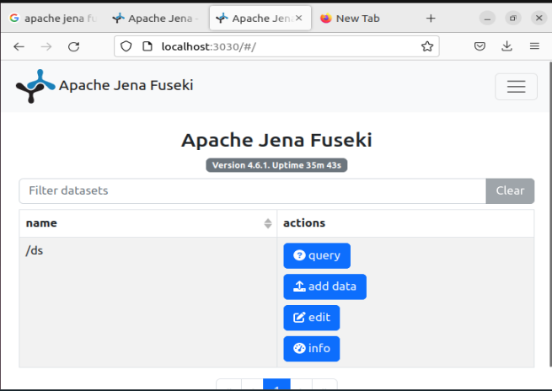

1. Click the navigation bar and go to manage to upload dataset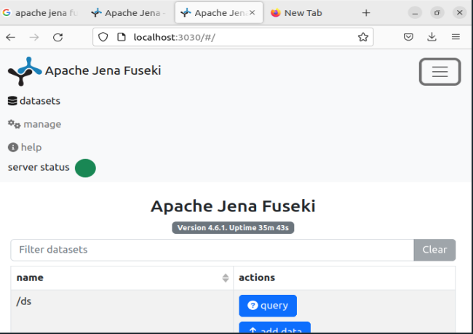
2. Click “add data” to upload “valueMapOntology”

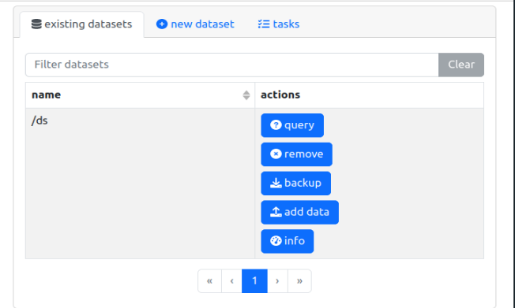

1. Upload the ontology

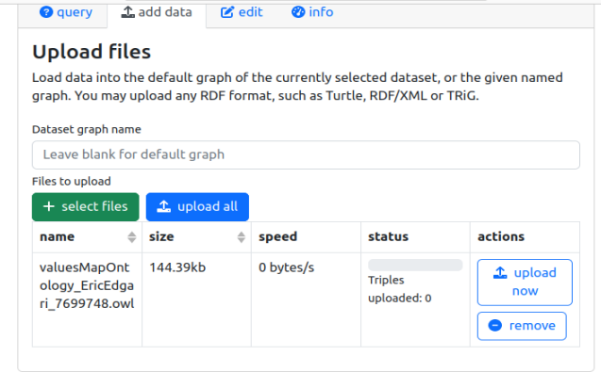

1. Run Sample Query

